Lab #10 b part

Question #1

Code

#include<iostream>

#include<iomanip>

#include<time.h>

using namespace std;

int main()

{

cout << "I have a number between 1 and 1000" << endl;

cout << "Can you guess my Number ?" << endl;

cout << "Please type your first Guess " << endl;

srand(time(0)); /\*Here the system will guess any Number\*/

int x = rand() % 1000;

int y;

cout << "Enter the number to be guessed :" ; /\*Here we are taking input \*/

cin >> y;

cout << endl;

while (y != x) /\*it will search guessing number if the entered number will not equal to number then loop will true otherwise loop will terminate \*/

{

if (y > x)

{

cout << "Too High" << endl;

}

else

{

cout << "Too Low " << endl;

}

cout << "Would you like to play again,So Enter any number :";

cin >> y;

system("cls");

}

system("pause");

return 0;

}

Output

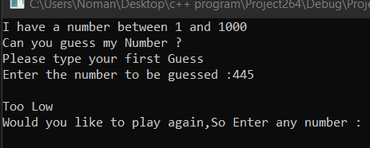

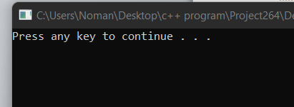

Task #3

Code:

#include <iostream>

using namespace std;

int main() {

int input[10], count, i, num;

cout << "Enter Number of Elements in Array";

cin >> count;

cout << "Enter " << count << " numbers ";

// Read array elements

for (i = 0; i < count; i++) {

cin >> input[i];

}

cout << "Enter a number to serach in Array";

cin >> num;

// search num in inputArray from index 0 to elementCount-1

for (i = 0; i < count; i++) {

if (input[i] == num) {

cout << "Element found at index " << i << endl;

break;

}

}

if (i == count)

{

cout << "Array is Empty ";

}

system("pause");

return 0;

}

Output

